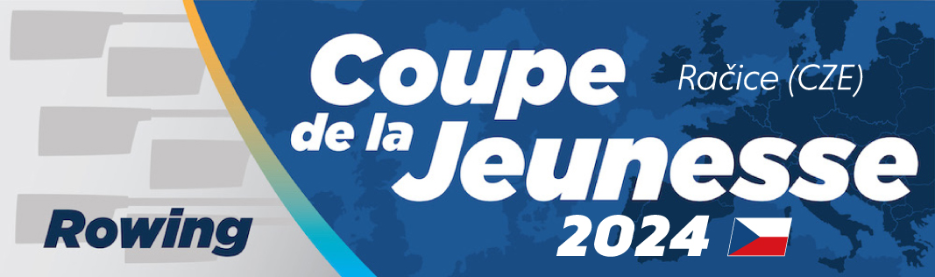

BIKE RENTAL, PRE - BOOKING FORM
(to be sent to makovickova@rowingracice.com as soon as possible)

Please note : Only Team Coaches are allowed to cycle on the course.

- Contact Information:

National Federation: _____________________________________________________________

Contact Person: _____________________________________________________________

Phone number: _____________________________________________________________

Email address: _____________________________________________________________

Number of bikes: _____________________________________________________________

Duration : _____________________________________________________________

Additional Comments: ____________________________________________________________

